**ASSIGNMENT 1**

**()**

**QUES 1**

<https://www.programiz.com/online-compiler/4VrT9wQHUGLLD>

#include <stdio.h>

#include <math.h>

int main()

{

//ques 1

int num, x, y, rem, sum;

printf("Enter a number:\n");

scanf("%d",&num);

x=num;

while(num!=0)

{

x=x/10;

y++;

}

while(num!=0)

{

rem=x%10;

sum+=pow(rem,y);

}

if(sum==num)

printf("%d is an Armstromg number.",num);

else

printf("%d is nor an Armstrong number.",num);

return 0;

}

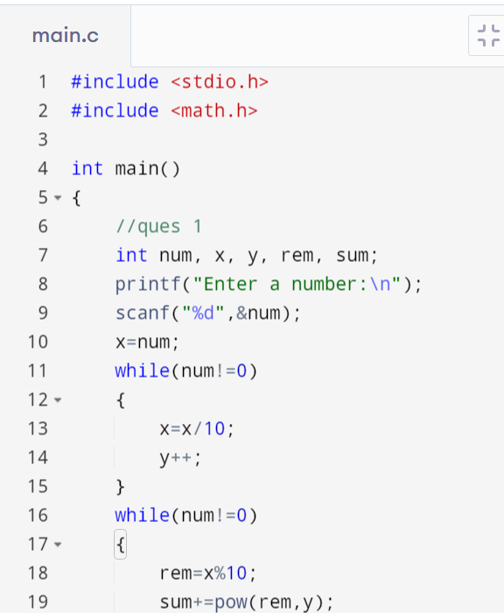

**QUES 2**

<https://www.programiz.com/online-compiler/0HdqHAYIELQza>

#include <stdio.h>

int main()

{

//ques2

int a,b,hcf;

printf("Enter two Integers:\n");

scanf("%d %d",&a,&b);

for(int i=2; i<=a,i<=b;i++)

{

if(a%i==0 && b%i==0)

hcf=i;

}

printf("HCF=%d",hcf);

return 0;

}

**QUES 3**

//WAP to subtract two integers without using Minus (-) operator.

#include <stdio.h>

#include <math.h>

int main()

{ // Ques 3

int a,b,Subtraction;

printf("Enter first no. = ");

scanf("%d",&a);

printf("Enter second no. = ");

scanf("%d",&b);

Subtraction=a+~b+1;

printf("Subtraction of two no. without using minus sign = %d",Subtraction);

return 0;

}

**QUES 4**

<https://www.programiz.com/online-compiler/5SqVSx5PA6dCp>

#include <stdio.h>

int main()

{

// ques 4

int a,b,t,orig_a,orig_b;

printf("Enter 2 Numbers:\n");

scanf("%d %d",&a,&b);

orig_a=a;

orig_b=b;

//method 1

t=a;

a=b;

b=t;

printf("Method 1\nAfter swapping a=%d and b=%d\n",a,b);

//method 2

a=orig_a;

b=orig_b;

a=a+b;

b=a-b;

a=a-b;

printf("Method 2\nAfter swapping a=%d, b=%d\n",a,b);

//method 3

a=orig_a;

b=orig_b;

a=a*b;

b=a/b;

a=a/b;

printf("Method 3\nAfter swapping a=%d, b=%d\n",a,b);

return 0;

}

**QUES 5**

<https://www.programiz.com/online-compiler/3JeDJhJET79pm>

#include <stdio.h>

int main()

{

//ques 5

int num,sum;

printf("Enter a number:\n");

scanf("%d",&num);

for(int i=1; i<num;i++)

{if(num%i==0)

sum+=i;}

if(sum==num)

printf("It's a Perfect Number");

else

printf("It's not a Perfect No.");

return 0;

}

**QUES 6**

<https://www.programiz.com/online-compiler/6lO1lsIs8XePl>

#include <stdio.h>

int main()

{

//ques 6

int x,y;

printf("Enter x,y coordinates:\n");

scanf("%d %d",&x,&y);

if(x>0 && y>0)

printf("First Quadrent");

else if(x<0 && y>0)

printf("Second Quadrent");

else if(x<0 && y<0)

printf("Third Quadrent");

else if(x>0 && y<0)

printf("Fourth Quadrent");

return 0;

}

**QUES 7**

**QUES 8**

<https://www.programiz.com/online-compiler/8vCt0YekNaQxh>

#include <stdio.h>

int main() {//ques 8

int i,j;

for(i=1;i<=5;i++)

{

for(j=1;j<=i;j++)

{

if(i%2==0)

{

if(j%2==0)

printf("1");

else

printf("0");

}

else

{

if(j%2==0)

printf("0");

else

printf("1");

}

}

printf("\n");

}

return 0;

}

**Ques10**

#include <stdio.h>

int main() {

int rows, i, j, space;

printf("Enter the number of rows: ");

scanf("%d", &rows);

for(i = 0; i < rows; i++) {

// Print leading spaces

for(space = 0; space < rows - i - 1; space++) {

printf(" ");

}

for(j = 0; j <= i; j++) {

// Calculate binomial coefficient (nCr)

int nCr = 1;

if(j > 0) {

nCr = (i * (i - 1)) / (j * (j - 1));

if(j > 1) {

for(int k = j + 1; k <= i; k++) {

nCr = nCr * (k - j) / (j + 1);

}

}

}

printf("%d ", nCr);

}

printf("\n");

}

return 0;

}